Initial results and comparison of previous models

*All the graphs presented in the papers were input into MATLAB using a function called GRABIT. It involves extraction of data points manually.*

**1 ) Borwankar, Wasan (1983)**

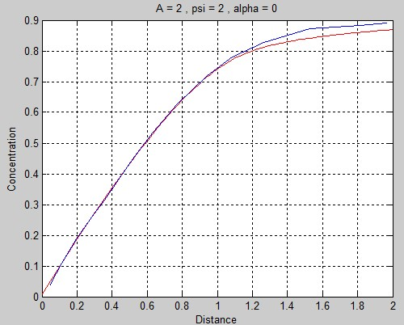

(Edit: The x-axis has been wrongly labelled ‘distance’. It represents ‘square root of time’)

In the above graph the blue curve is the one presented in the paper. The red one has been reproduced.

Observation :

The two curves overlap for most part, but seem to differ slightly towards the end. This is probably because of the way the equations are written.

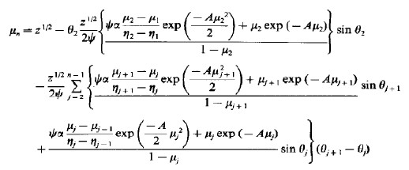

Clearly, the value at nth time instant depends on all the previous time instants. Therefore the errors in each of them will add up.

**2) MacLeod, Radke (1994)**

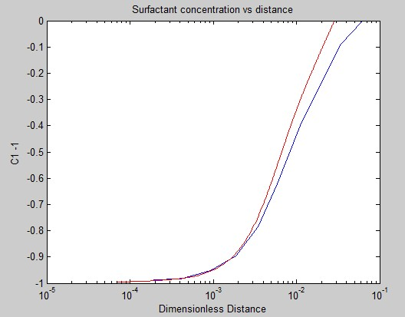

In the above graph the blue curve is the one presented in the paper. The red one has been reproduced.

Observation:

The two curves overlap only for a small region in the domain.

In the program, a far away distance has its C1 value set to 1 (since the boundary condition at infinity demands it). In the above run, it has been set to 1 at a distance 10-2 away from the interface.

If we set the ‘infinite’ distance further away from the interface, we will need a lot more number of grids to evaluate it accurately. This will increase the program running time. If we replace the difference equations and solve them implicitly we will be able to get the results in shorter time. This modification is still pending.

**3) Extension to Particles**

*The code was run after making the following assumptions*.

A (Ӷ) = 50 x (Ӷ/Ӷmax)

Beta = 106 (Adsorption rate constant. Set high so that it is diffusion limited)

Diffusivity (non-dimensional) = 10-2

Equilibrium constant = 106 (Making the process effectively irreversible)

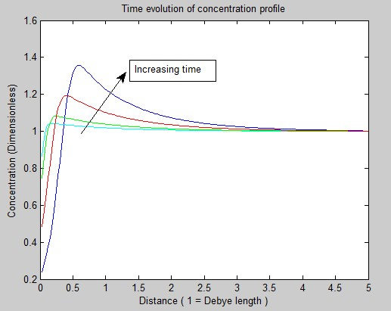

The concentration of particles is rising above the value at infinity. The following might explain.

* Diffusivities of particles are generally lower.
* We made an assumption on potential. It is dependent only on interface concentration.

We can get more accurate results by using the formulae for potential that has been already used in MacLeod.